**📊 Project Report: Google Trends Keyword Analysis**

**📌 Project Title:**

**Global Keyword Trends Analysis Using Google Trends and Python**

**🎯 Project Objective:**

To analyse keyword search trends across countries and over time, using Python and Google Trends data, to support data-driven decision-making.

**🧠 Key Concepts:**

* Keyword Trend Analysis
* Country-wise & Time-wise Search Insights
* Related Keyword Comparison
* Data Visualization

**🧪 Technologies Used:**

* Google Trends (Pytrends)
* Python (Pandas, Matplotlib, Seaborn)
* Plotly / Folium
* Jupyter Notebook

**❓ Questions & Short Conclusions:**

**1. Dynamic Keyword Search Function**  
*Conclusion:* A reusable function allows keyword trends to be fetched dynamically with minimal changes — increasing efficiency.

**2. Top 15 Countries & Visualization**  
*Conclusion:* The top 15 countries with the highest keyword interest were identified and visualized using a bar chart.

**3. World Map of Keyword Searches**  
*Conclusion:* A global map was created to visually show countries with high search interest — useful for targeting international audiences.

**4. Time-wise Keyword Trend**  
*Conclusion:* Trends over time revealed how keyword popularity changed across years — helpful for spotting seasonality or shifts.

**5. Related Keyword Comparison**  
*Conclusion:* Related keywords were compared in a line graph to see which topics are rising or declining — guiding better content strategies.

**Let’s do code:**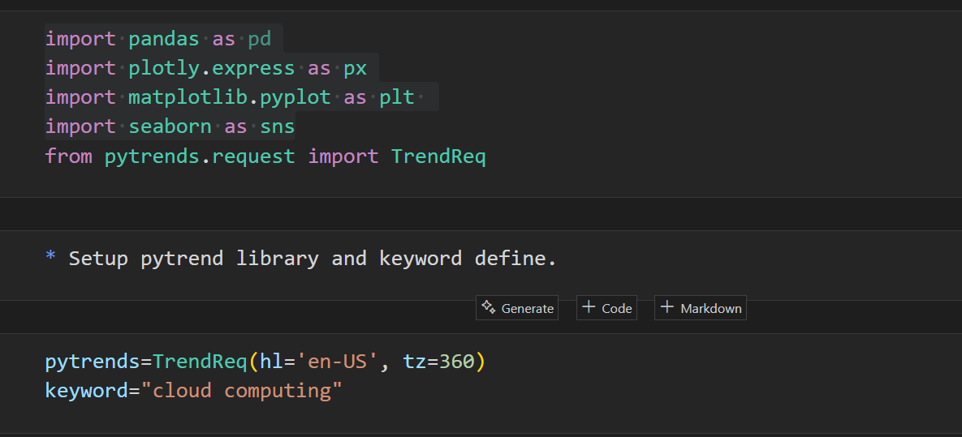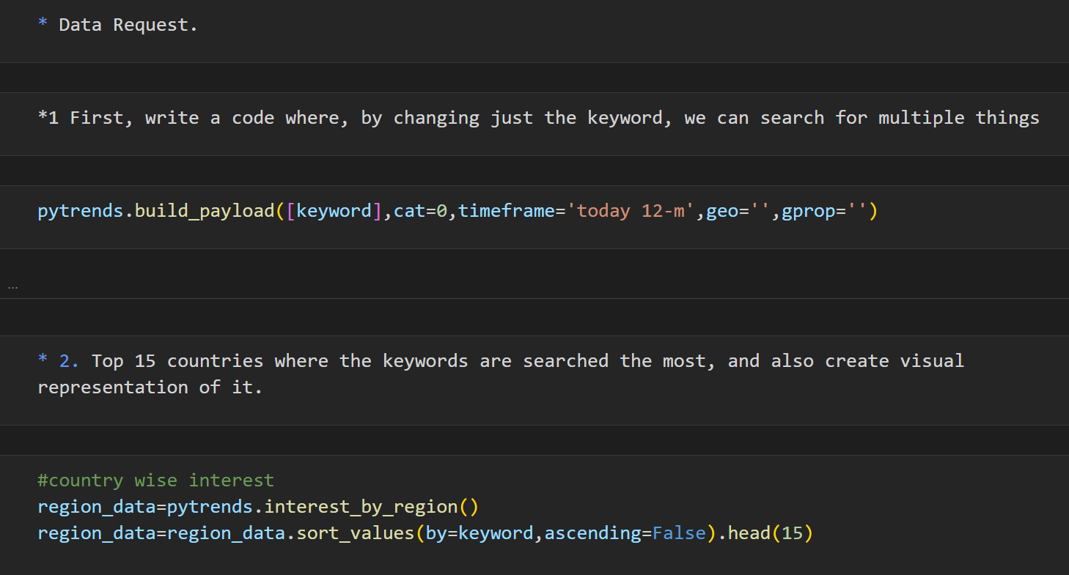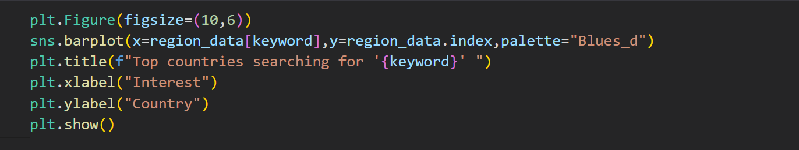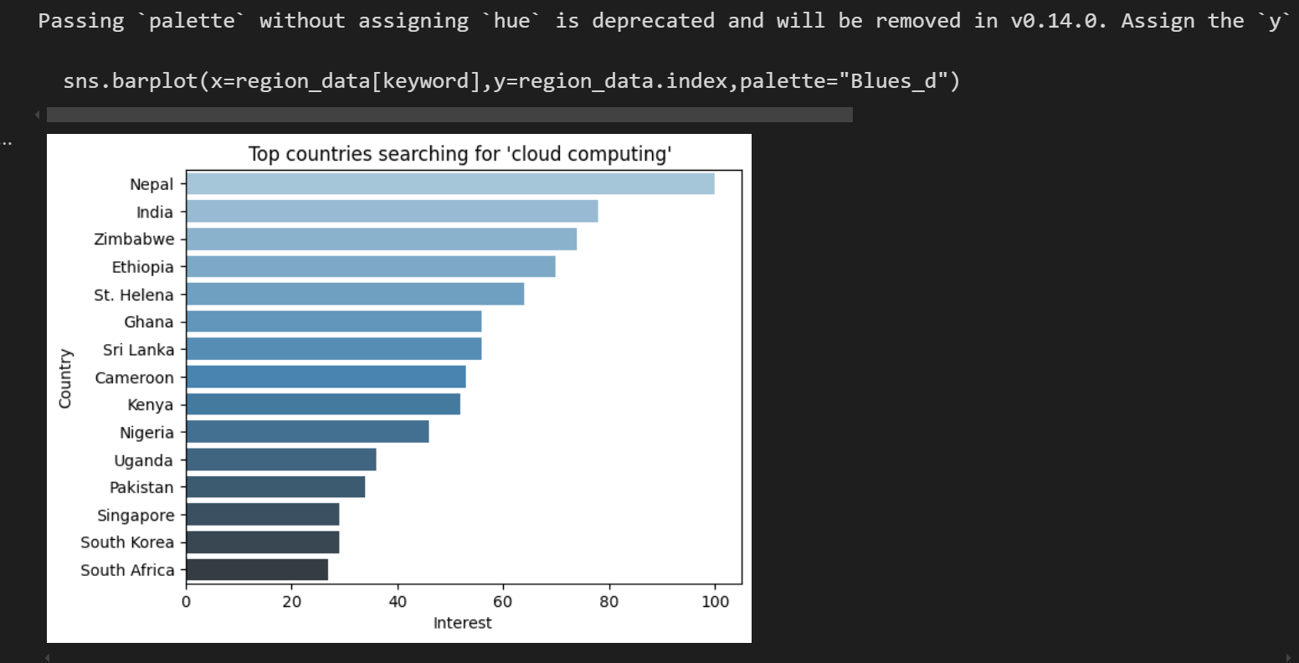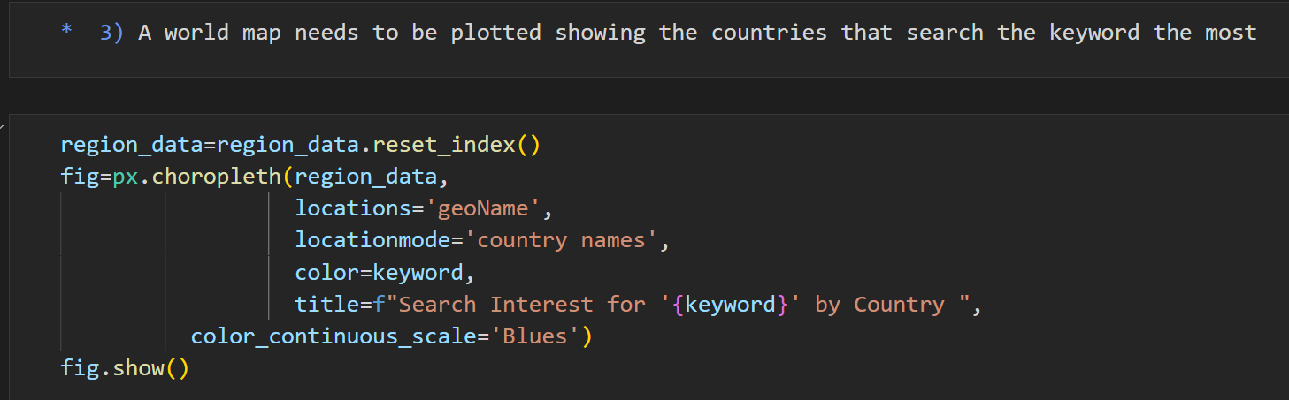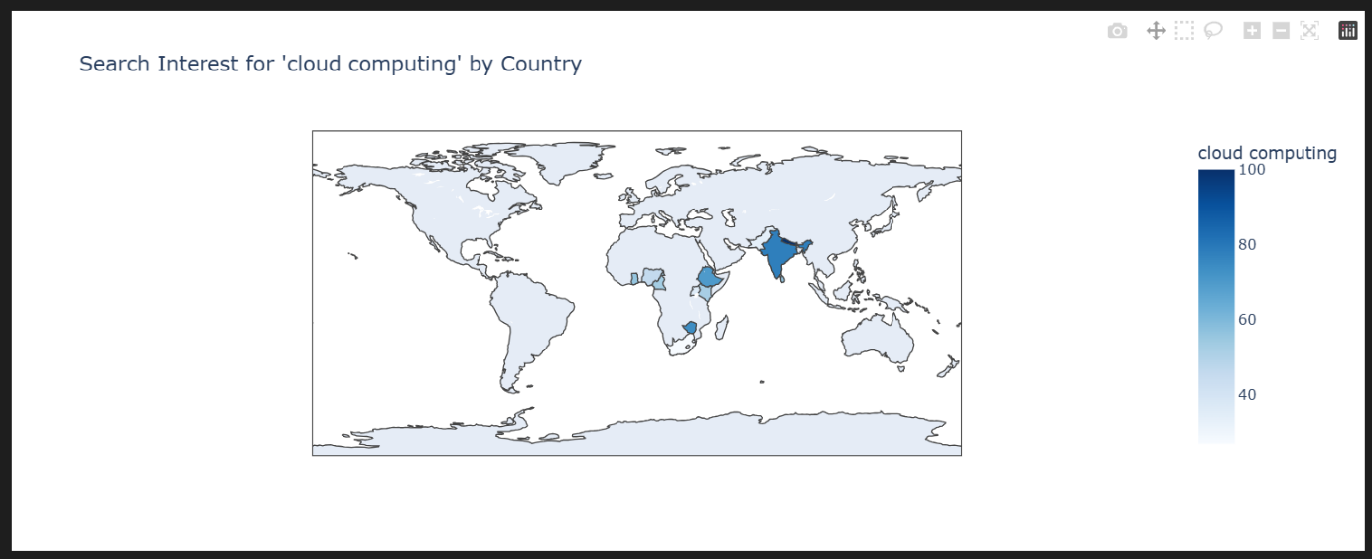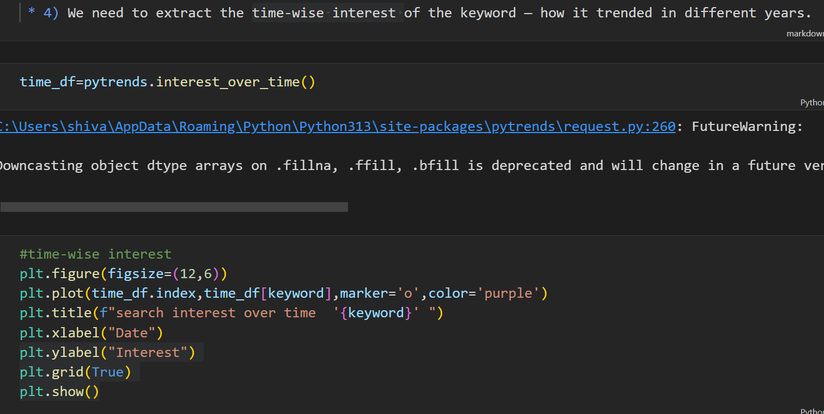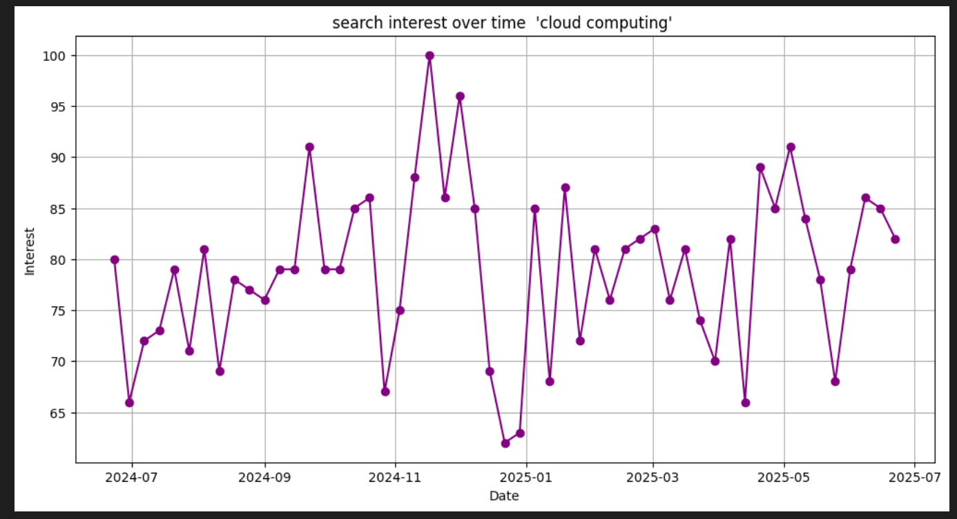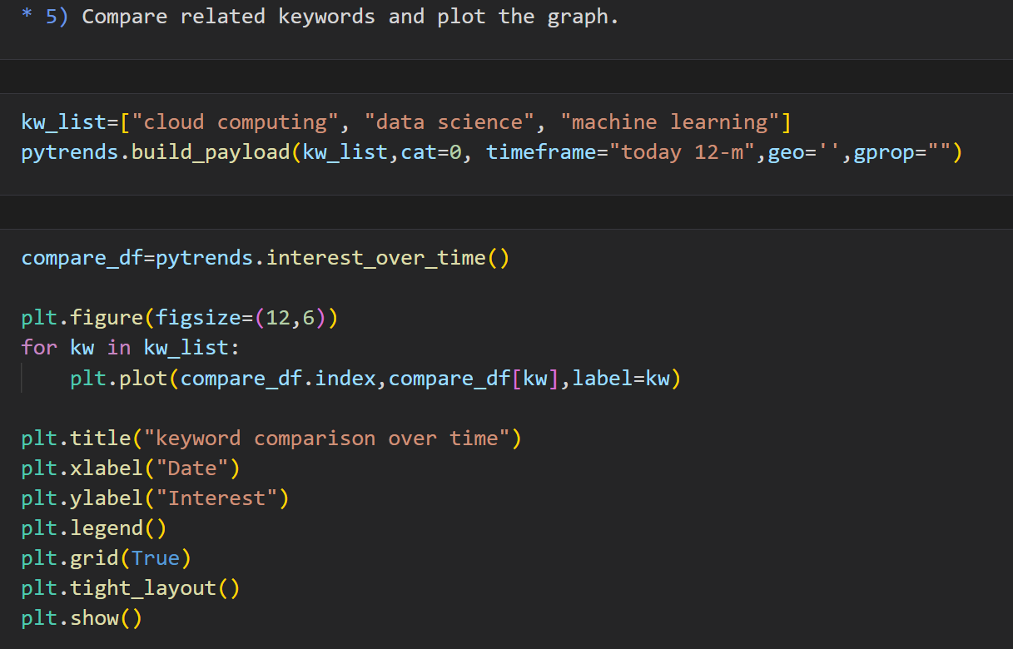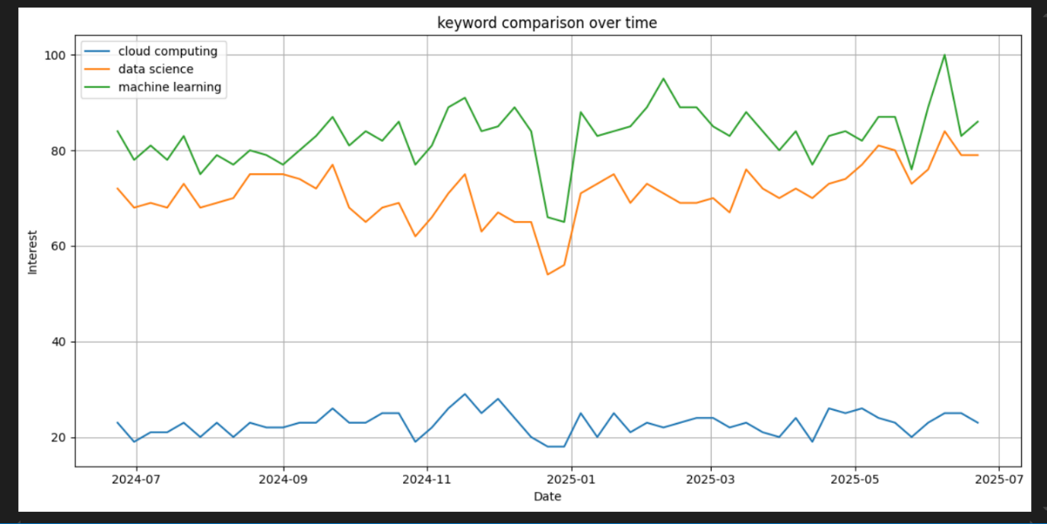

**📝 Final Summary:**

This project offers a simple and scalable way to analyse keyword trends using Python and Google Trends. It helps understand regional interest, time-based popularity, and related keyword patterns — essential for SEO, marketing, and digital growth.